**Big Data Lab 3**

**MapReduce In Hive**

**Gaurav Ankalagi J004**

**Aim: Word Count Using Hive**

Step 1: Create a text file with some words in it. Make sure it has some words repeating it so that the word count program is able to show up some repeated words and not frequency for each word as 1.

Step 2: Move the created file to the Hadoop file system using the command hadoop fs -put data.txt data.txt Launch hive and put the file in in a table using the command > LOAD DATA INPATH 'data1.txt' OVERWRITE INTO TABLE FILES; 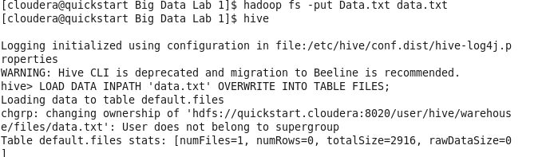

Step 3: Create a table word word_count to store the frequency of each word in the table.

> CREATE TABLE word_count AS

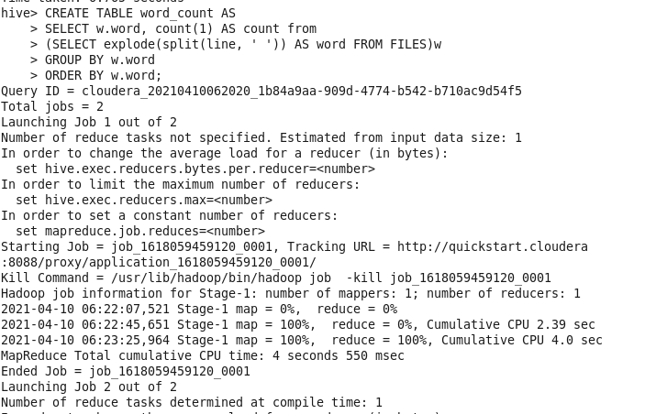

> SELECT w.word, count(1) AS count from

> (SELECT explode(split(line, ' ')) as word from FILES) w

> GROUP BY w.word

> ORDER BY w.word;

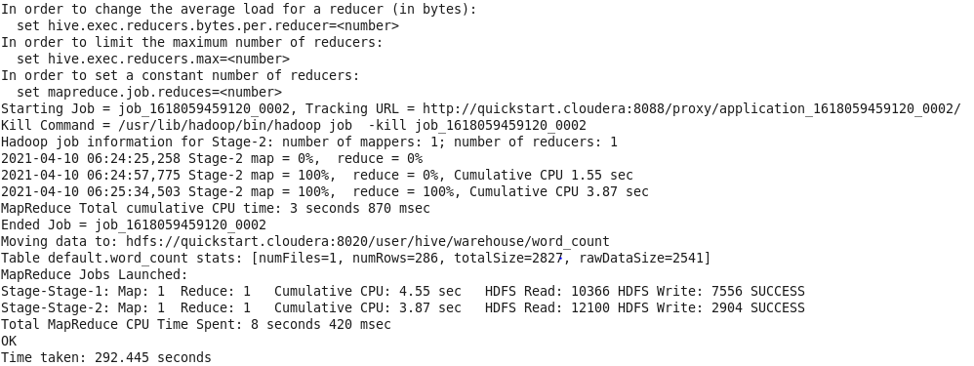

Step 4: Displaying the word counts stored in the word_count table with command.

> select * from word_count;

